
Bhoj Reddy Engineering College for Women (Sponsored by Sangam Laxmibai Vidyapeet, approved by AICTE and affiliated to JNTUH) Vinaynagar, IS Sadan Crossroads, Saidabad, Hyderabad – 500 059, Telangana. www.brecw.ac.in

12 June 2023
Report of Guest Lecture on “Opportunities and Challenges in Electric Vehicles”
The EEE Department has organized a Guest Lecture on “Opportunities and Challenges in Electric Vehicles” for II, III & IV B Tech EEE students during 10 June 2023, Guest Lecture was scheduled from 10:30 to 12:30 Hrs.
Inaugural function was attended by the Speaker Dr Vikranth Racherla, Principal Dr E Madhusudhana Reddy, EEE-HOD Mrs S Deepti, Workshop in-charge Mrs R Manju Bhargavi, EEE staff and II, III and IV EEE students. The venue was Seminar Hall WB-402.
Speaker:

Dr Vikranth Racherla
Professor, IIT Kharagpur & Prof-in-Charge for Centre for Railway Research(CRR), Associate Head-Center for Rural Development and Innovative Sustainable Technology

He completed his Post doctorate in paris. He completed his PhD in Mechanical Engineering and Applied Mechanics, May 2007 at UNIVERSITY OF PENNSYLVANIA. He completed his B. Tech. in Mechanical Engineering, May 2002 in INDIAN INSTITUTE OF TECHNOLOGY, MADRAS

Banner:
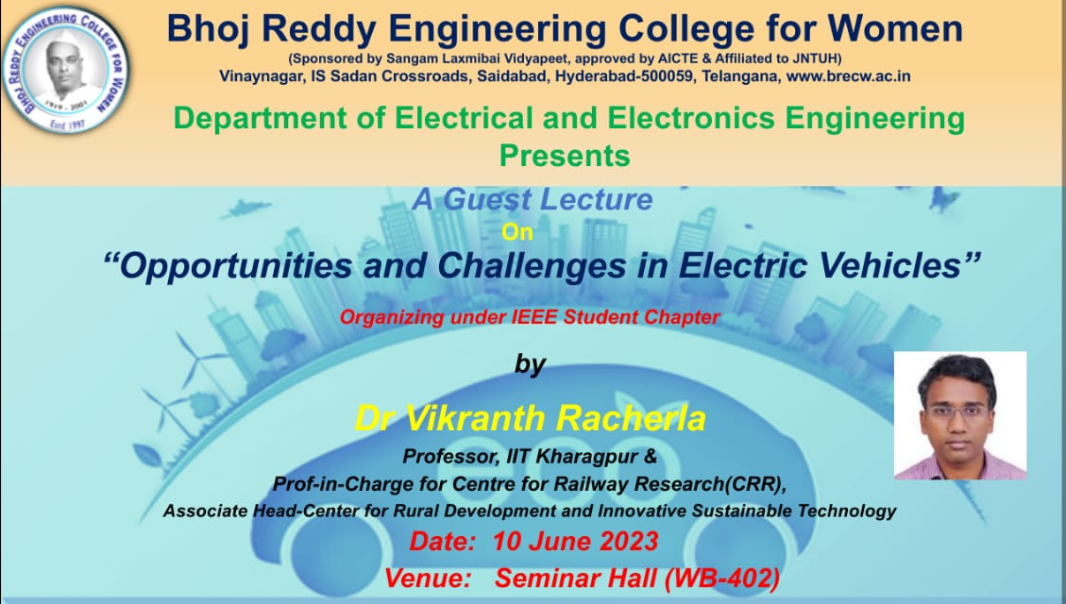

Schedule:
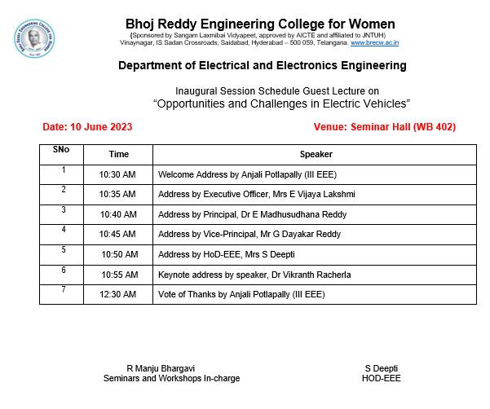
On the Forenoon of 10 June 2023, the Department of Electrical Engineering at Bhoj Reddy Engineering College for Women hosted a guest lecture on "Opportunities and Challenges in Electric Vehicles." The speaker was Dr Vikranth Racherla, an expert in Electric Vehicles and an accomplished academician with over 20 years of experience in the field. The lecture was attended by I,II, III and IV Btech students and faculty members from the EEE department.
Dr Vikranth Racherla began his lecture with an introduction to electric vehicles and their potential to revolutionize the transportation industry. The speaker highlighted the environmental benefits of electric vehicles, including the reduction of greenhouse gas emissions and the improvement of air quality. The speaker also mentioned the benefits of energy independence, cost savings, technological innovation, and job creation associated with the widespread adoption of electric vehicles.
Dr Vikranth Racherla then delved into the challenges associated with electric vehicles. The speaker discussed the high upfront cost of electric vehicles, which can deter some consumers from purchasing them. The limited driving range of electric vehicles was also highlighted as a challenge that can limit the appeal of electric vehicles to consumers who need to travel long distances. The lack of a comprehensive charging infrastructure was also discussed, which can make it difficult for electric vehicle owners to find charging stations and limit their ability to travel long distances. The speaker also mentioned the challenges associated with battery technology, including the cost, range, and lifespan of electric vehicle batteries. The production of electric vehicles relies on a complex global supply chain, which can be vulnerable to disruptions and may raise concerns about ethical sourcing of materials.
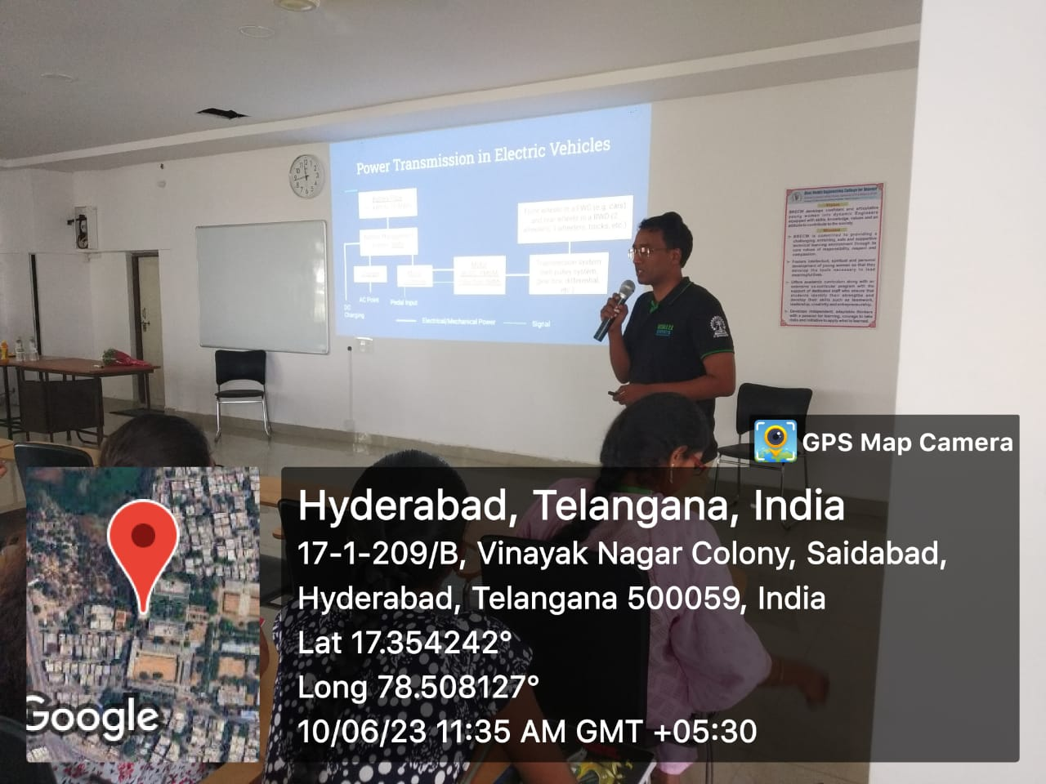
Dr Vikranth Racherla concluded with a discussion on the need for collaborative efforts from governments, the private sector, and consumers to develop innovative solutions that can promote the widespread adoption of electric vehicles. The speaker emphasized the importance of addressing the challenges associated with electric vehicles to ensure a sustainable and equitable future.
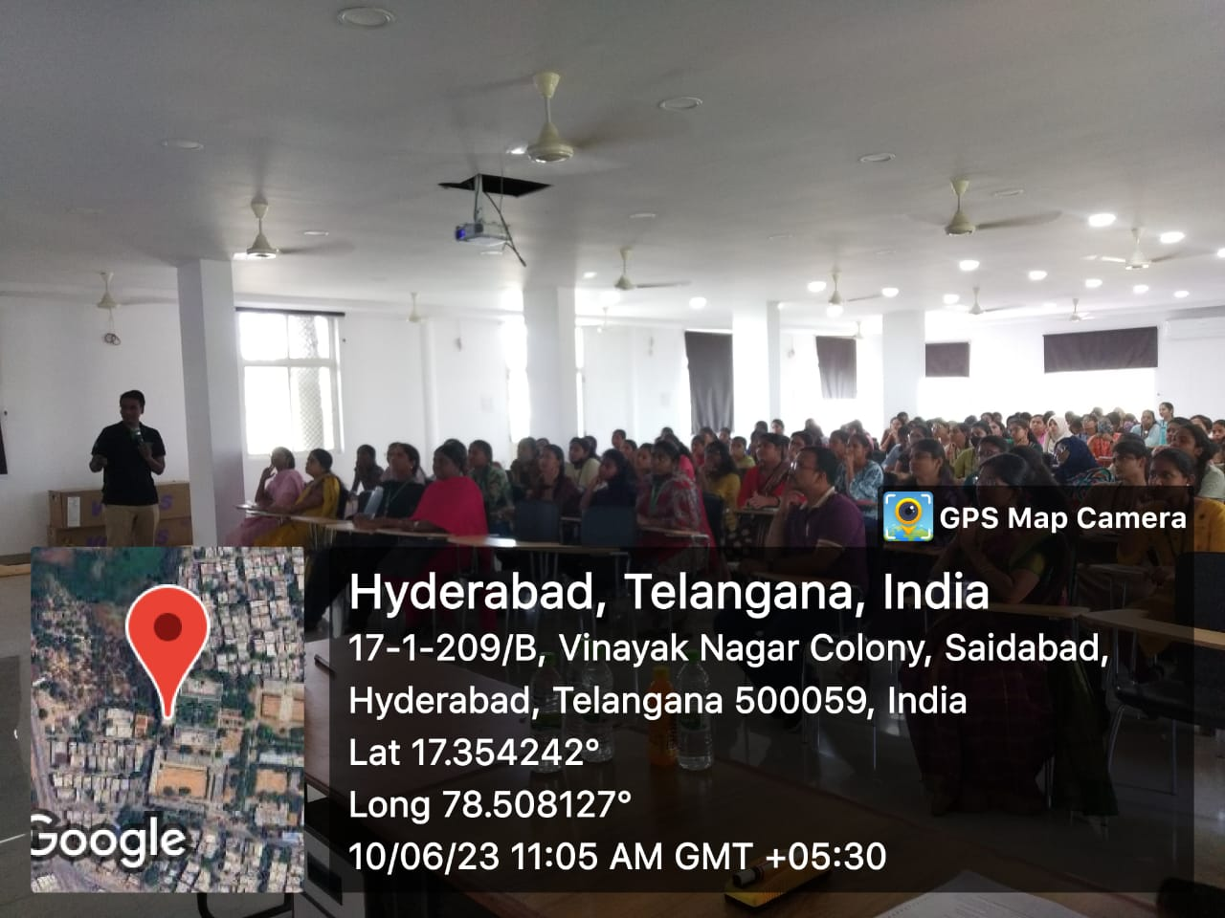
Figure 1: During the lecture of Vikranth Racherla garu

Overall, the guest lecture was informative and engaging, and it provided valuable insights into the opportunities and challenges associated with electric vehicles. The lecture provided a platform for students and faculty members to learn about the latest developments in the electric vehicle industry and to discuss potential solutions to the challenges associated with electric vehicles.
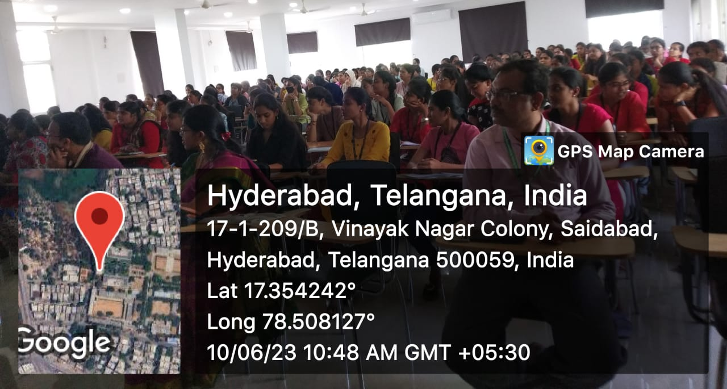

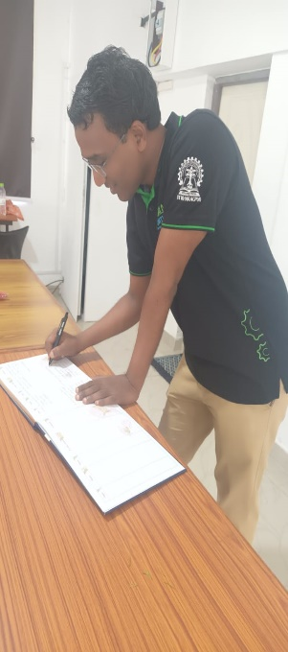

The Feedback from the students was taken. Overall feedback of the Guest Lecture is Excellent and active participation of students during the lecture was notable, and students were engaged throughout the session. Students thoughtful questions and insightful comments added a lot of value to the overall discussion. We could tell that students have a good grasp of the subject matter as the lecture was informative and enlightening. In future, we can encourage students to continue attending such events and to keep learning and growing in their field of interest.
Sample feeback form:
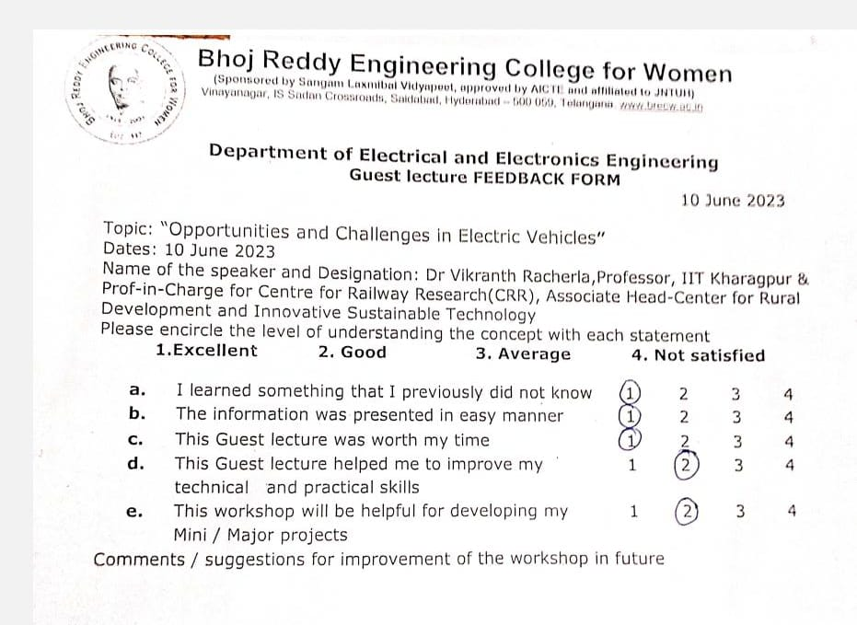

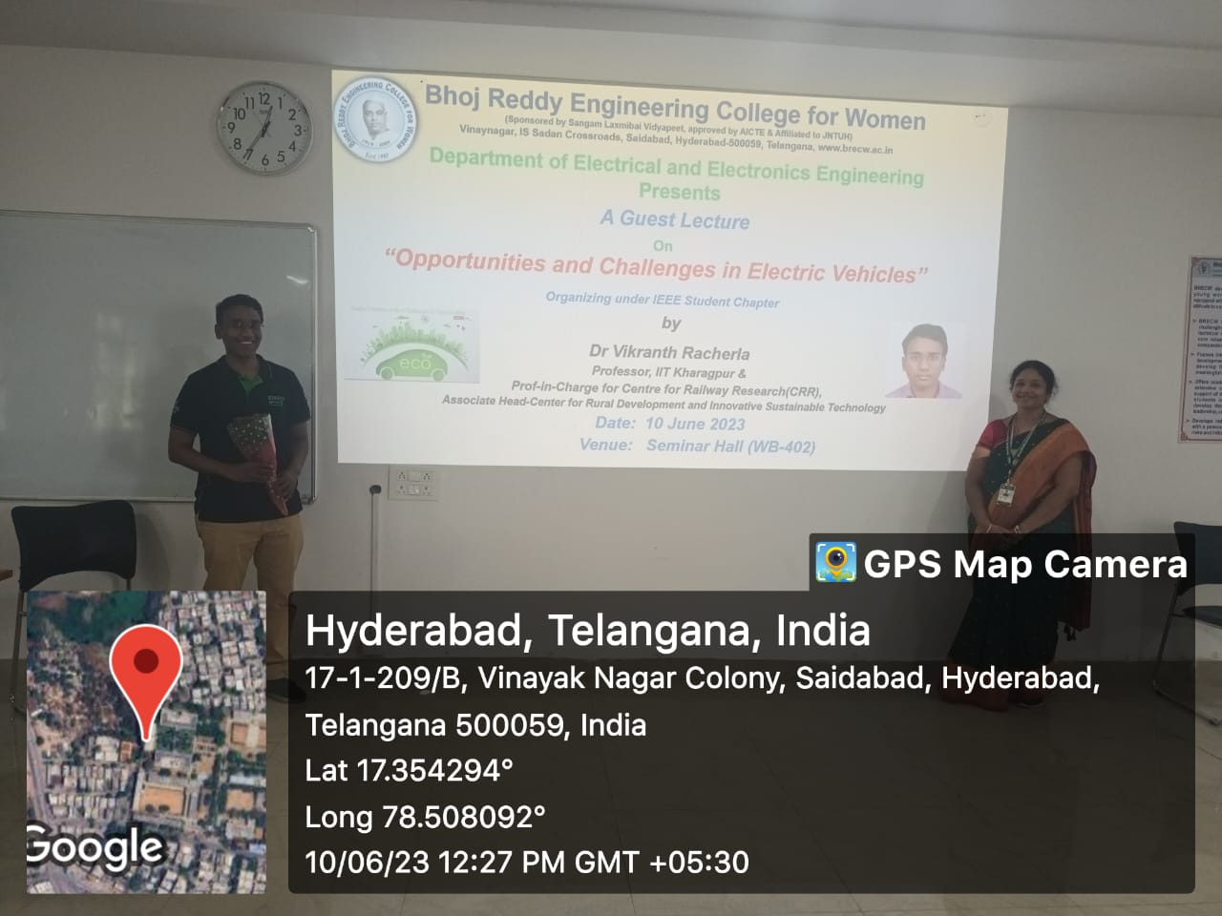
Figure 2: During valedictory ceremony, Mr Vikranth Racherla and R Manju Bhargavi, Seminars and Workshops In-charge

R Manju Bhargavi, Seminars and Workshops In-charge faculty expressed her sincere gratitude for allowing EEE department with and the opportunity to conduct a guest lecture at BRECW. She appreciated the support that management gave and said it was informative session. Once again, she said thank you for allowing them to contribute to the learning and development of their students and the session was concluded by the vote of thanks by Anjali, a student of III EEE.

