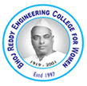
Bhoj Reddy Engineering College for Women (Sponsored by Sangam Laxmibai Vidyapeet, approved by AICTE and affiliated to JNTUH) Vinaynagar, IS Sadan Crossroads, Saidabad, Hyderabad – 500 059, Telangana. www.brecw.ac.in

Department of Electrical and Electronics Engineering

Report on Farewell Day-2023

BRECW has organized “Farewell Day-2023” for all students. The event was celebrated on 7 June 2023, from 9:45 am to 4:00 pm for the EEE department. On 7 June 2023, from 9:45 am to 12:30 pm. Farewell Day was co-ordinated by S Deepti, Associate professor, HOD-EEE and department cultural co-ordinators R Manju Bhargavi, Associate professor (EEE);along with the staff and cultural coordinators from all classes and monitored by Dr E Madhusudana Reddy, Principal, G Dayakar Reddy, Vice Principal. All the students of I,II,III,IV year of EEE department have actively participated.

The farewell day celebration is a momentous event in the life of every graduating batch at an engineering college. It serves as an opportunity for students to bid farewell to their alma mater, reflect on their academic journey, and embark on a new chapter in their lives. The farewell day celebration at BRECW was organized by the student council, with support from the faculty and administration. The planning process commenced several weeks in advance, with a dedicated committee appointed to oversee various aspects of the event. This committee was responsible for venue selection, decorations, invitations, guest arrangements, and the overall coordination of the event.The farewell day event was held at a spacious Indoor auditorium, Ramdev Block, within the college premises. The stage was beautifully designed to accommodate speeches, performances, and other activities.
The farewell day program was carefully crafted to encompass a range of activities that would provide a fitting tribute to the graduating batch.
The Cultural program started at 9:45 am at Indoor Auditorium, Ramdev Block with a song and followed by the scheduled dances and songs. The list of programs for Farewell Day day were Solo singing, Solo dance, Duet dance, Group dance, Skit, Many students have participated enthusiastically in all the programmes.

The schedule included:

a. Welcome Address: The event commenced with a warm welcome address, expressing gratitude to the students for their contributions to the college and offering words of encouragement for their future endeavours.

b. Speeches: Students were invited to deliver speeches, sharing their experiences, insights, and advice. They recalled fond memories, highlighted achievements, and acknowledged the challenges faced by the graduating batch.

c. Cultural Performances: Students showcased their talents through various cultural performances, including Solo song, Duet dance, Group dances etc. These performances added entertainment and emotional value to the event, allowing the students to express their creativity and bid farewell in an expressive manner. The event provided an opportunity for students to express their gratitude and bid farewell to their teachers, staff members, and peers. They could write personalized messages or record video messages, expressing their appreciation and sharing their hopes for the future. Certificates, trophies, and other tokens of appreciation were presented to deserving individuals.

d. Lunch and Socializing: A grand lunch was organized in the premises of polytechnic college, allowing students to socialize, reminisce, and cherish the final moments together. This informal gathering facilitated a sense of camaraderie and provided an opportunity for the graduating batch to strengthen their bonds before parting ways.

The farewell day celebration was a memorable event, filled with emotions, celebrations, and reflections. Through its well-planned activities and thoughtful organization, the event provided a fitting tribute to the graduating. The Cultural program was completed around 4:00Pm with vote of thanks.

Annexure – 1: Banner
Annexure –2: Schedule of the programs & Invitation
Annexure –3: Photos

Co-ordinator HOD-EEE Vice- Principal Principal
R Manju Bhargavi S Deepti G Dayakar Reddy E Madhusudana Reddy

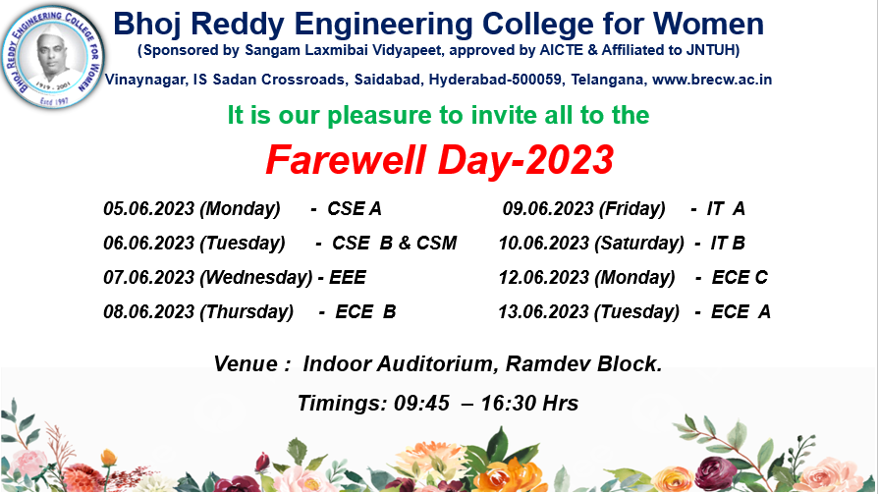

Figure 1: Banner

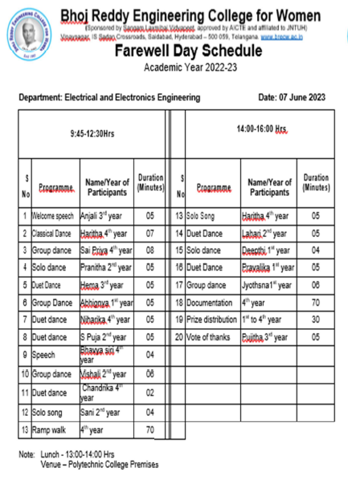
Figure 2: Schedule

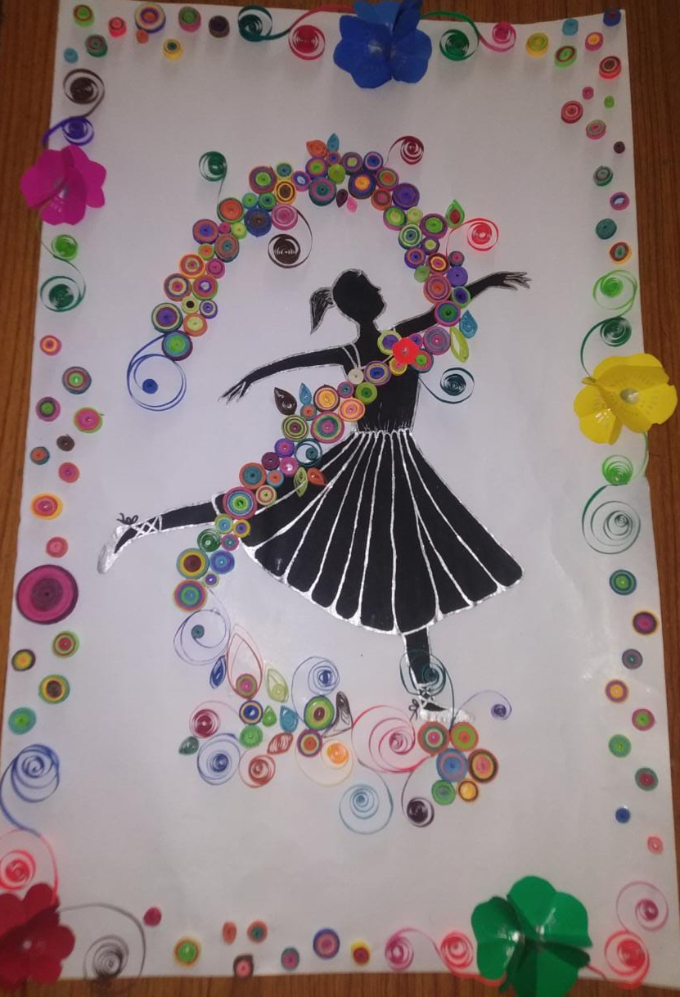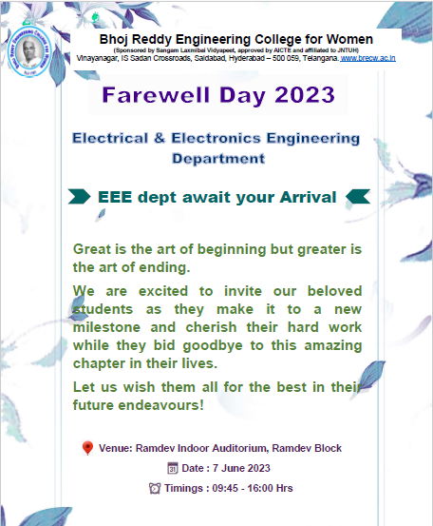
Figure 3: Invitation card

Now, coming to the winners of the event

Classical Dance
1st prize- Haritha from IV year

Semi Classical Dance
1st prize- Haritha and Chandrika from IV year

Solo Song
1st prize- Haritha from IV year
2nd prize- Sani Azeem from II year

Duet Dance
1st prize- Hema and Lavanya from III year
2nd prize- Pravalika and Deepti from I year

Group dance
1st prize- Sai priya & Group from IV year
2nd prize- Vaishali & Group from II year

Special Performance
1st prize- Nanadini, Prasanna, Srihitha and Chandrika from III & IV years

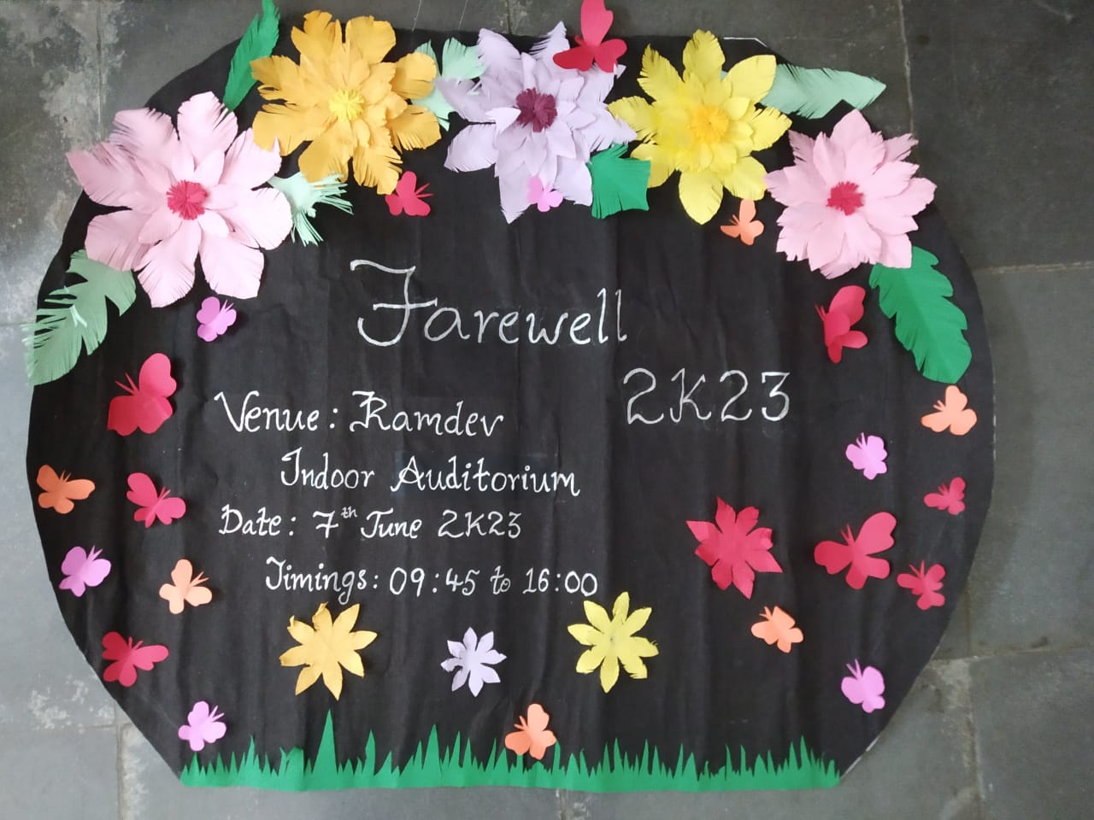
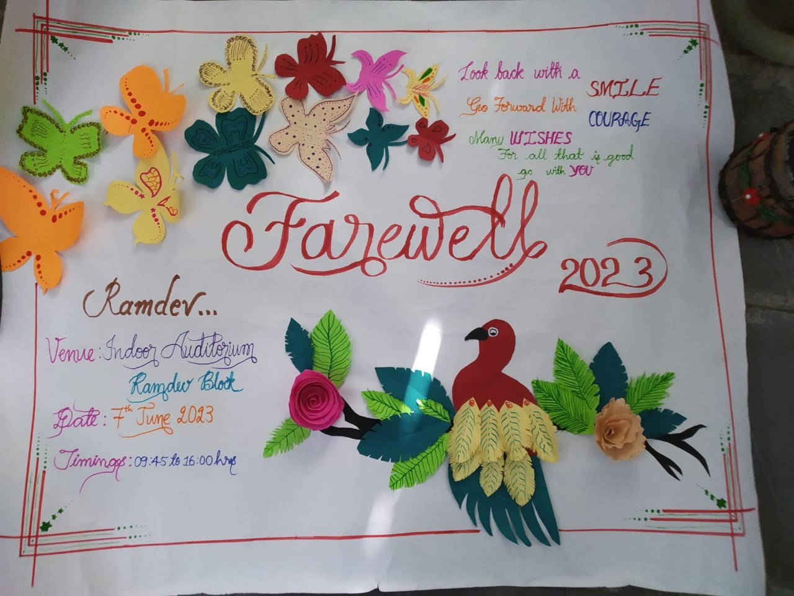

Figure 4: Posters

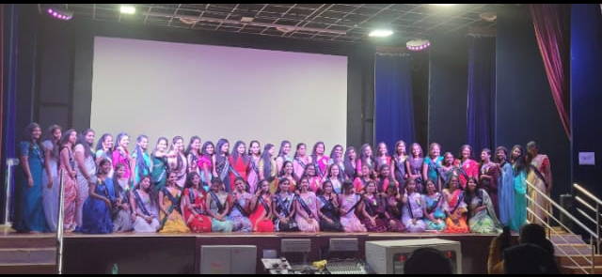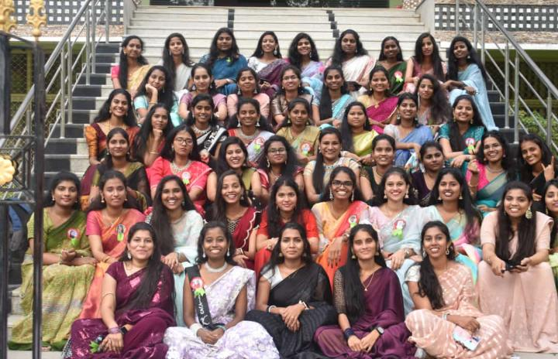

Figure 5: IV BTech students (19th batch) along with their titles student’s

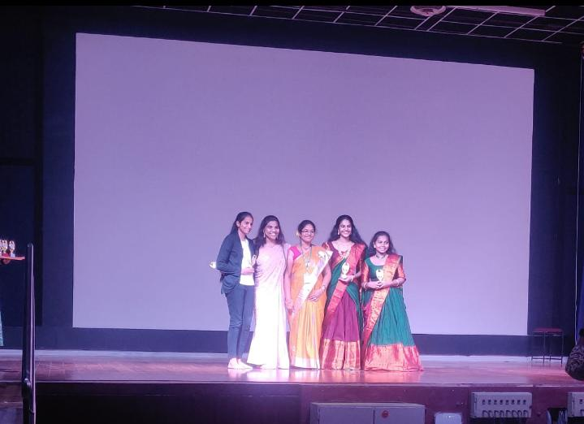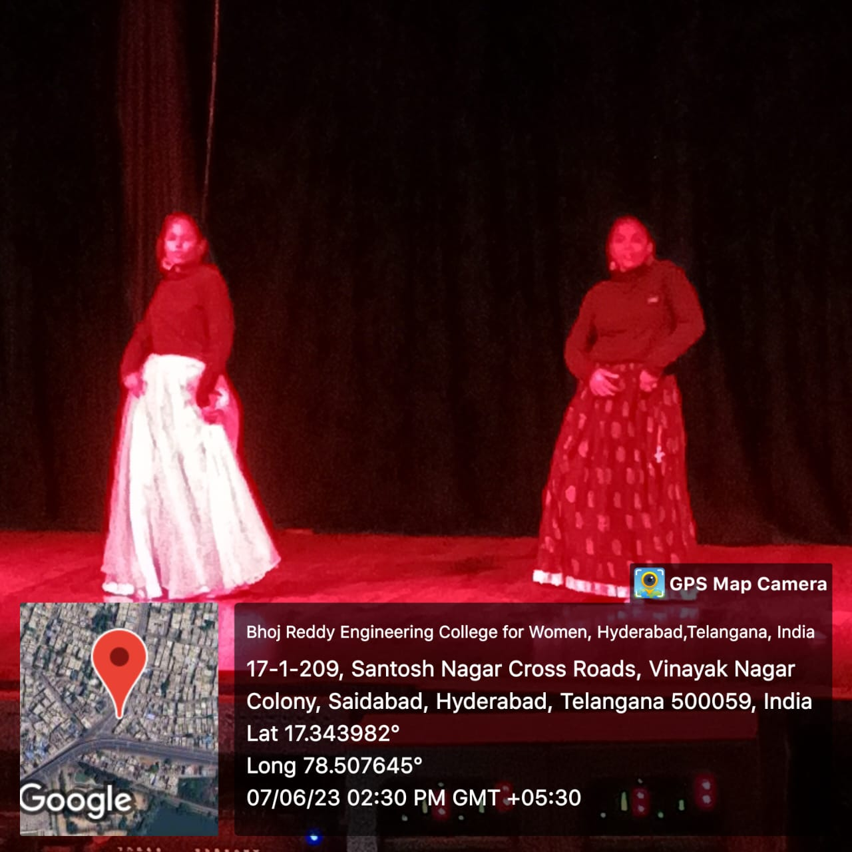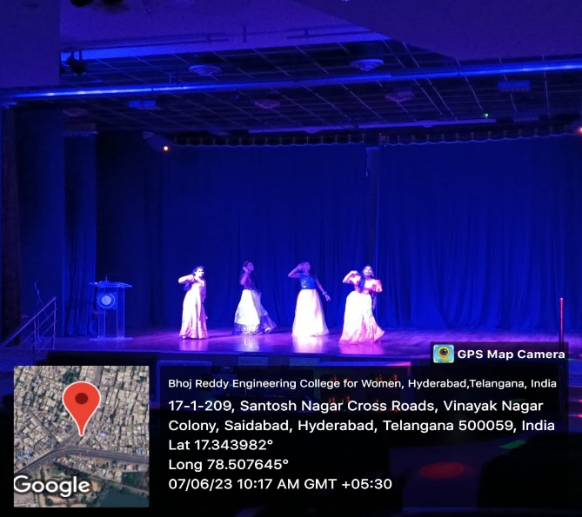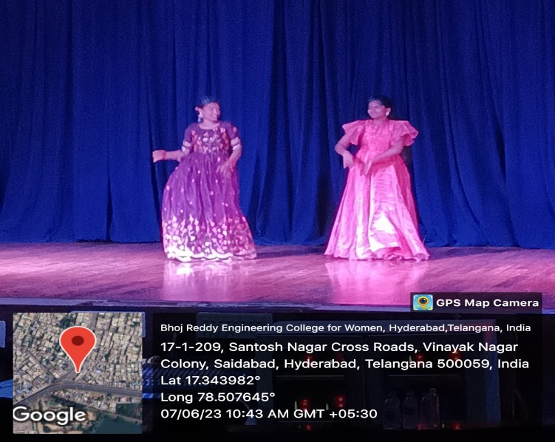
Figure 6: Student’s cultural programs
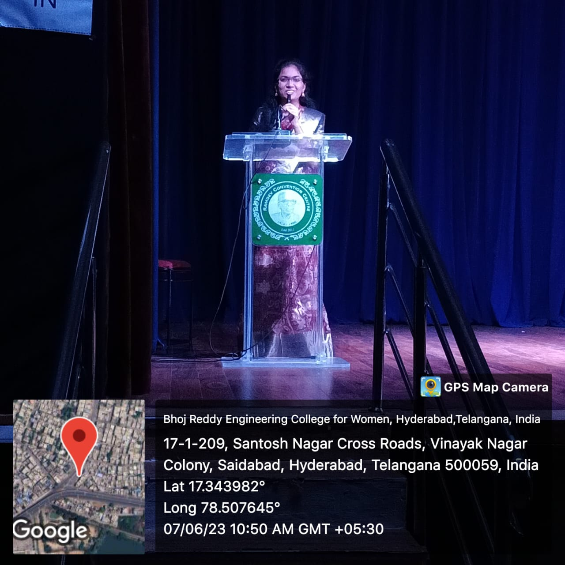

Figure 7: Speech by a IV EEE student Bhavya

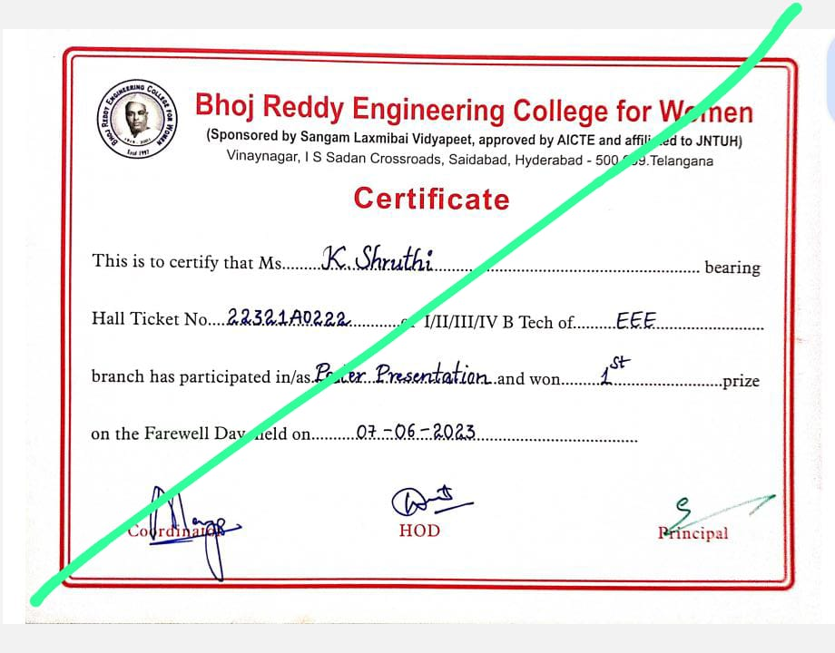
Figure 8: Certificate sample

