
Bhoj Reddy Engineering College for Women (Sponsored by Sangam Laxmibai Vidyapeet, approved by AICTE and affiliated to JNTUH) Vinaynagar, IS Sadan Crossroads, Saidabad, Hyderabad – 500 059, Telangana. www.brecw.ac.in

15 March 2023
Report on two-day workshop on “Designing of Solar PV Systems”
EEE Department has organized a two-day workshop on “Designing of Solar PV Systems” for III BTech EEE students on 13-14 March 2023. 53 (III EEE) students got registered. The workshop was scheduled from 09:30 to 16:30 Hrs.
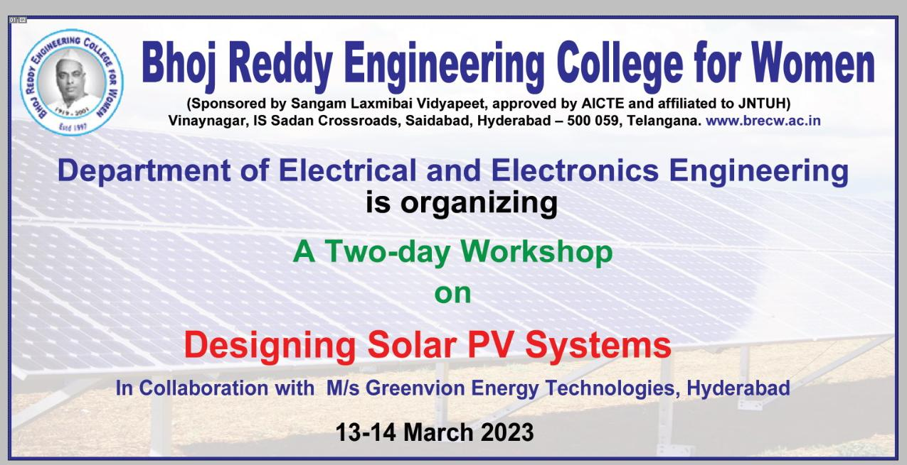
Schedule :
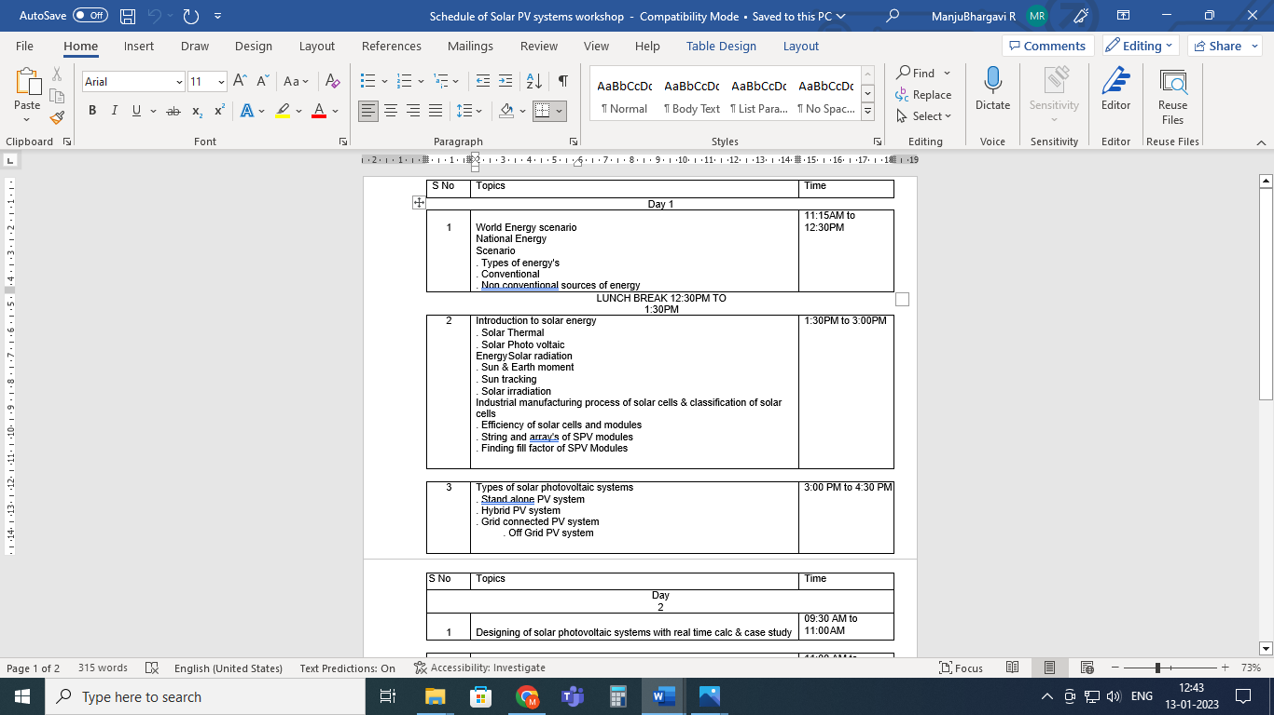
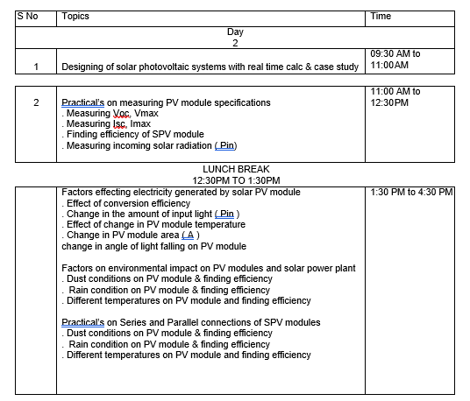

The workshop was conducted by Greenvion Energy Technologies, Hyderabad.
The first day (13 March 2023) started with an inaugural function.
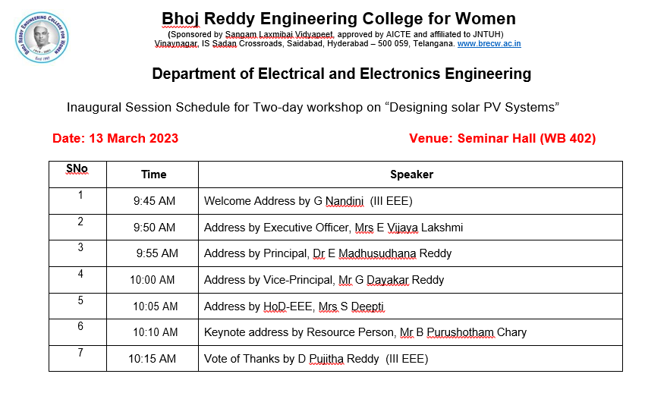
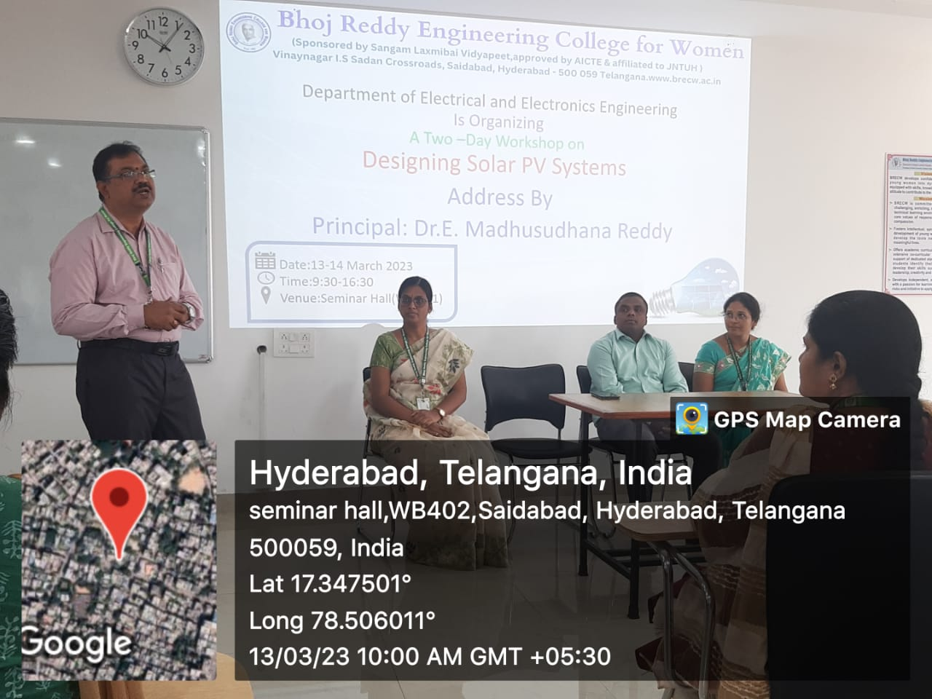
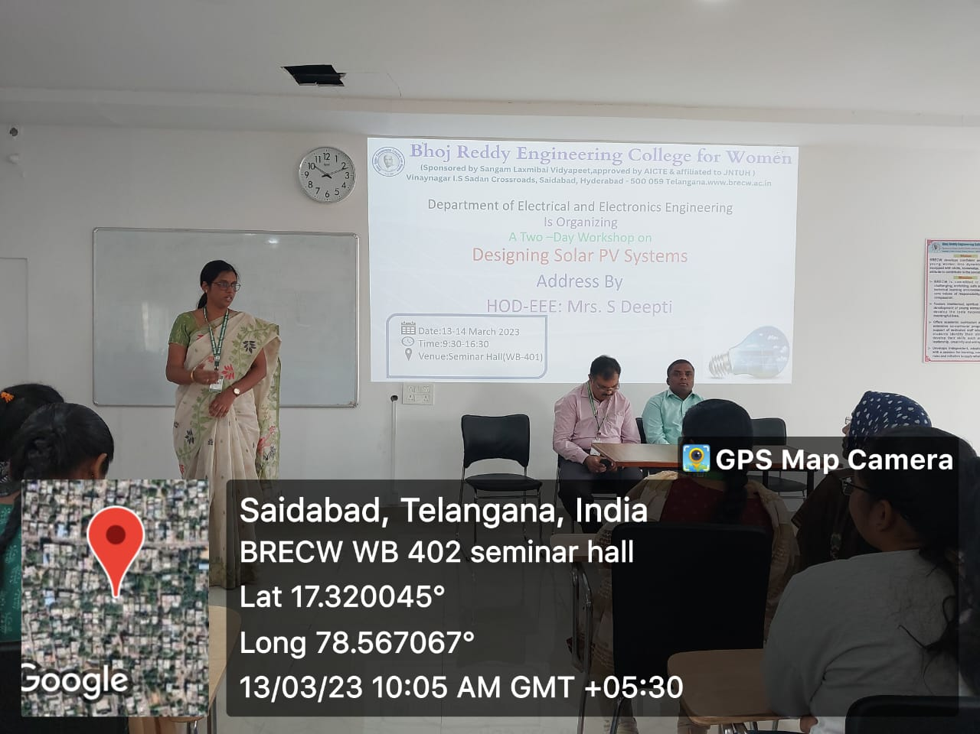
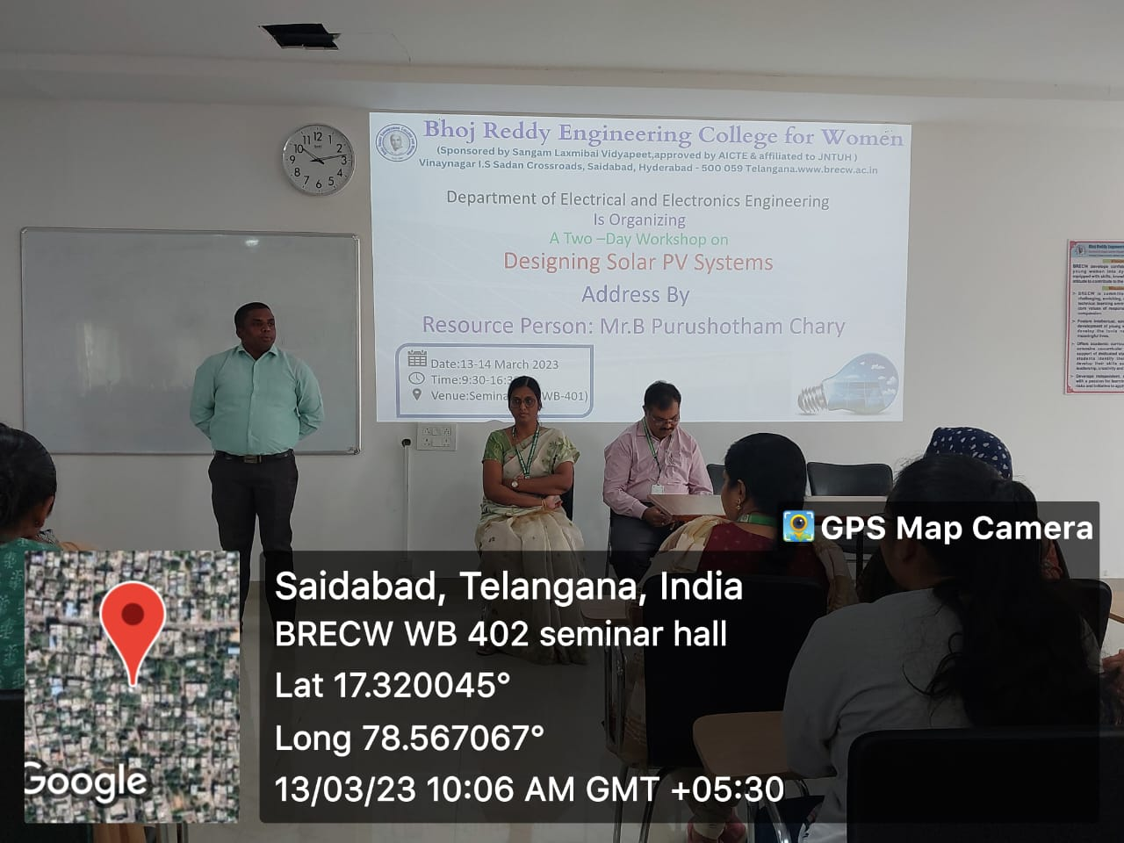
Solar PV systems have become increasingly popular in recent years due to their ability to generate clean energy and reduce reliance on fossil fuels. However, designing an efficient and effective solar PV system requires careful planning and attention to detail.
In the forenoon session of workshop, students learnt the designing a solar PV system, which is to determine the energy requirements of the building or facility where the system will be installed. This involves calculating the energy consumption of the building, including the lighting, heating, and cooling systems, as well as any other electrical appliances. This information will be used to determine the size of the solar PV system needed to meet the energy demand. Then they learnt to conduct a site analysis to determine the optimal location for the solar PV system. This includes assessing factors such as the orientation and angle of the roof or ground, shading from trees or other structures, and the climate of the region. The analysis will help determine the size and type of solar panels needed for the system, as well as the best location for the panels to maximize energy production.
Afternoon session of the workshop was dealt with the basics of the Present Energy Scenario in India Types of PV systems, Power and energy calculation. The afternoon session was on Components of solar Photo-Voltaic system, Load analysis, Component selection, battery safety, Voltage drops, controllers, commissioning procedures. Then learnt to select the components for the solar PV system. This includes selecting the solar panels, inverters, batteries (if necessary), and other components required the system to function. The selection of components should be based on the energy requirements of the building, the site analysis, and the available budget. System Design involves determining the number of panels, the configuration of the panels, and the sizing of the other components to ensure that the system can meet the energy requirements. The design should also take into account any shading or other factors that may affect the performance of the system.
In the second day (14 March 2023) of the workshop, Forenoon session started with financial analysis and how to install a solar Photo-Voltaic system. The afternoon session was a practical session. This involves mounting the panels, connecting the components, and testing the system to ensure that it is working properly. Installation should be carried out by qualified professionals to ensure that the system is installed safely and correctly. At last students learnt that regular maintenance is essential to ensure that the system continues to function properly over time. This may include regular inspections, cleaning the panels, and replacing components as necessary. For this, students are divided into ten groups and practicals are conducted on solar panels. The students analyzed a solar photo-voltaic module and calculated the performance of solar photo-voltaic module.
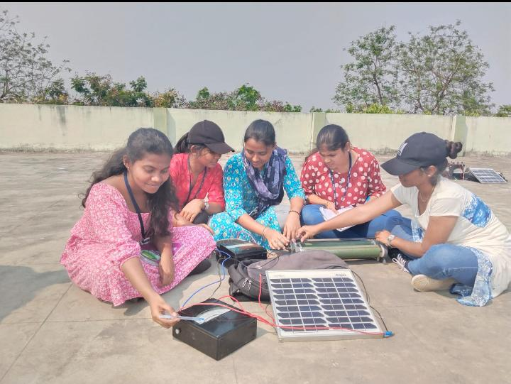
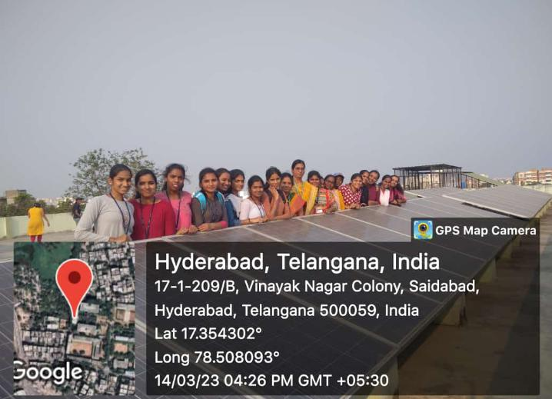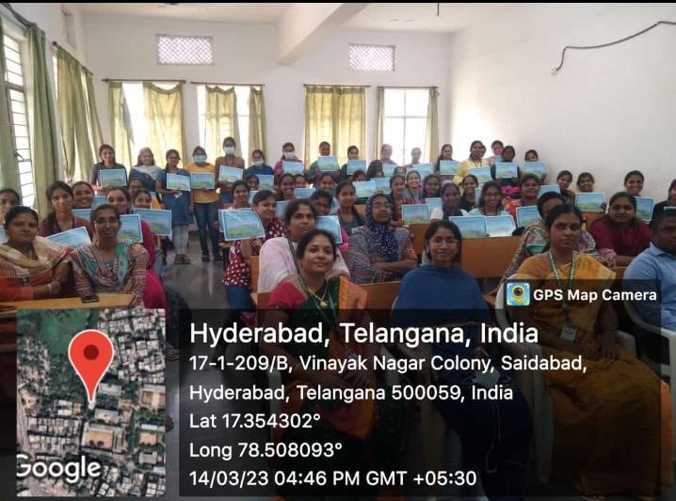
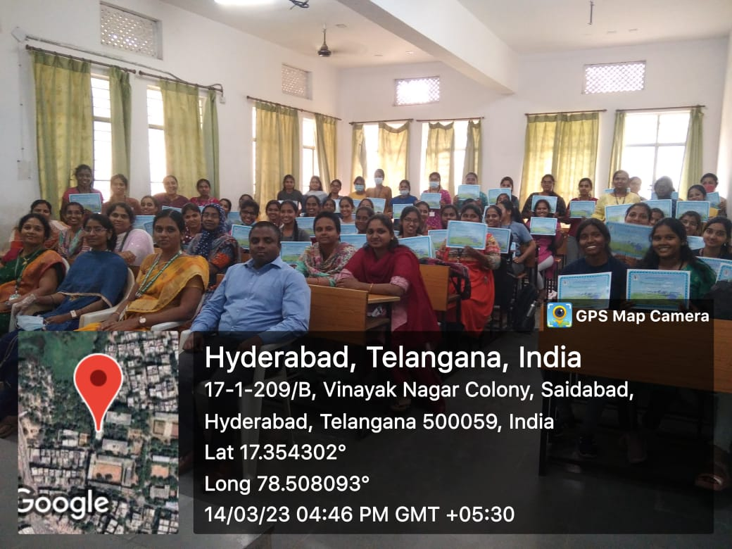
All the participants were given the participation certificates in the valedictory function at the end of second day.
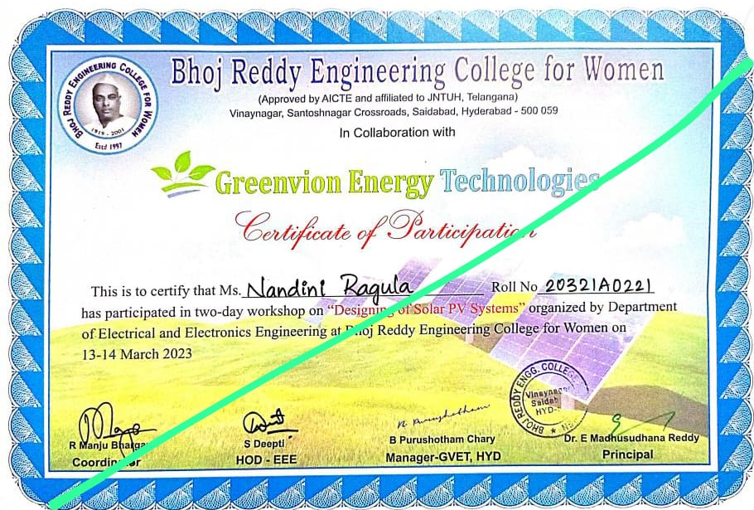

Sample feedback form is attached for reference.
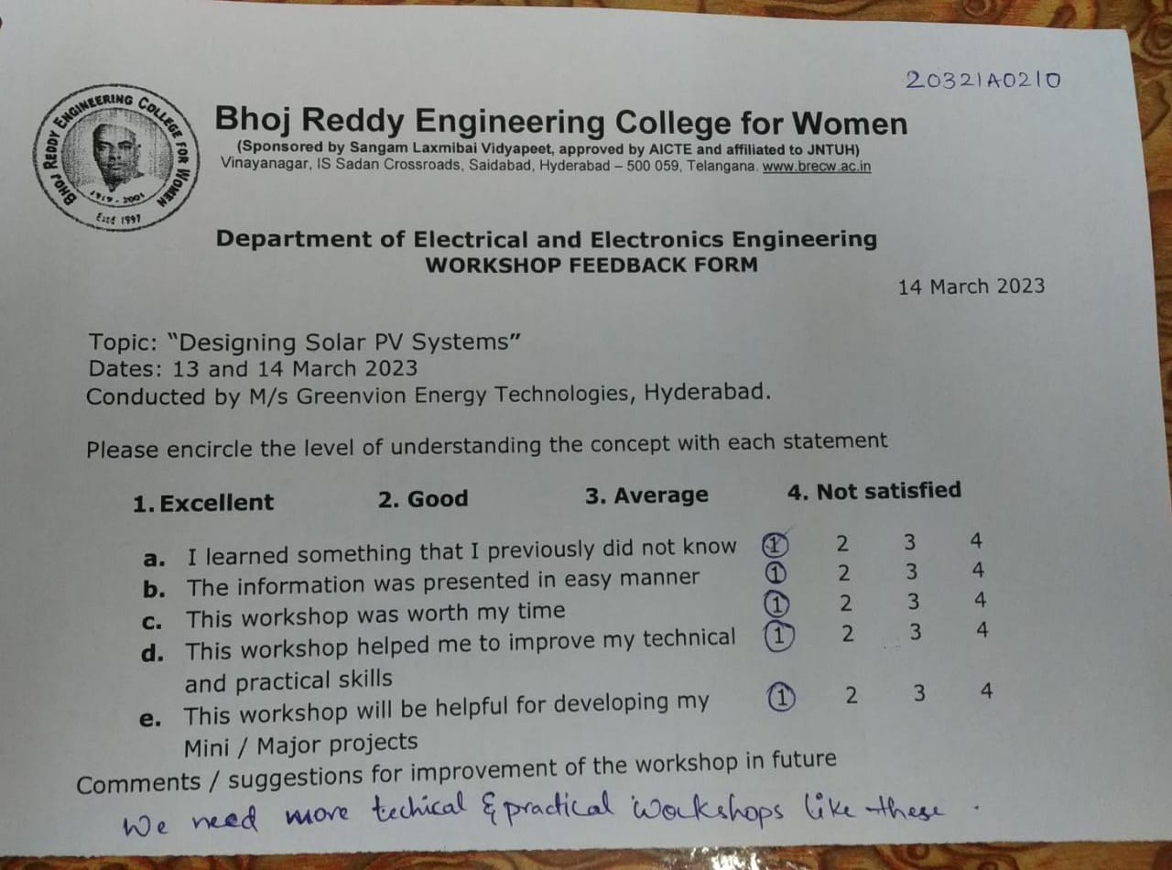
The Feedback from the students was collected. Total 53 students provided the feedback. Overall feedback of the workshop is good.

R Manju Bhargavi S Deepti
Seminars and Workshops In-charge HOD-EEE

