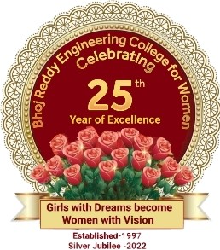
Bhoj Reddy Engineering College for Women
(Sponsored by Sangam Laxmibai Vidyapeet, approved by AICTE and affiliated to JNTUH)
Vinayanagar, IS Sadan Crossroads, Saidabad, Hyderabad – 500 059, Telangana. www.brecw.ac.in
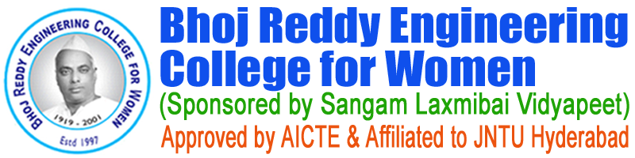

Fresher’s day Report

Fresher’s Day EEE department ( 7 December 2022 )
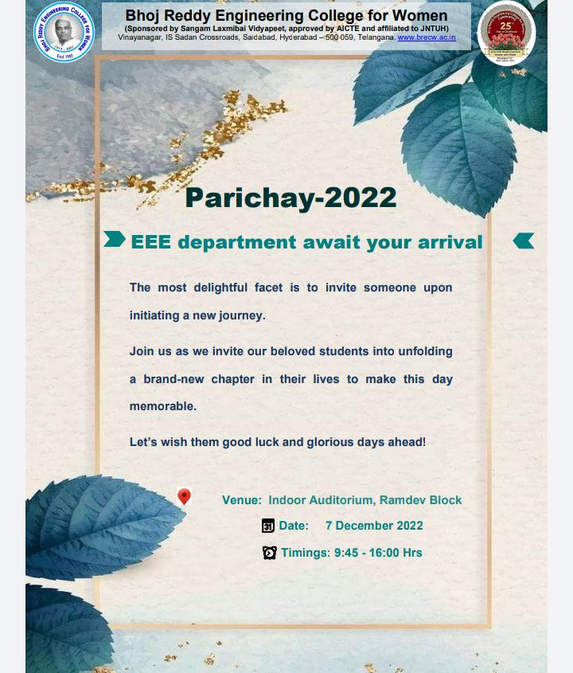

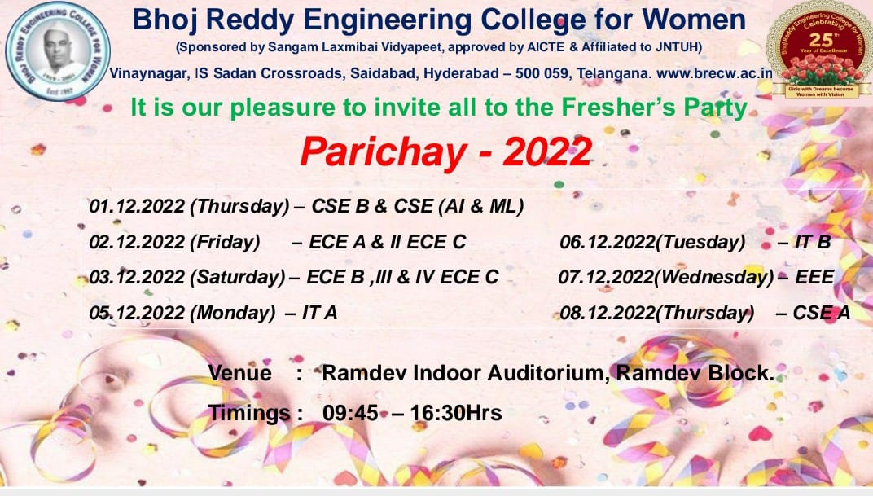

Fresher’s Day EEE department ( 7 December 2022 )
BRECW has organized “Freshers Day-2022” for all students in December 2022. EEE department has celebrated fresher’s day on 7 December 2022, from 9:45 am to 4:00 pm. On 7 December 2022, from 9:45 am to 12:30 pm there were several events including the ramp walk, then there was an hour break for lunch in the premises of polytechnic college. After lunch the event continued, and many students performed different activities. Freshers Day was co-ordinated by S Deepti, Associate professor, HOD-EEE and department cultural co-ordinator R Manju Bhargavi, Associate professor (EEE); along with the staff and student cultural coordinators from all classes and monitored by Dr E Madhusudana Reddy, Principal, G Dayakar Reddy, Vice Principal. All the students of I,II,III,IV year of EEE department have actively participated.
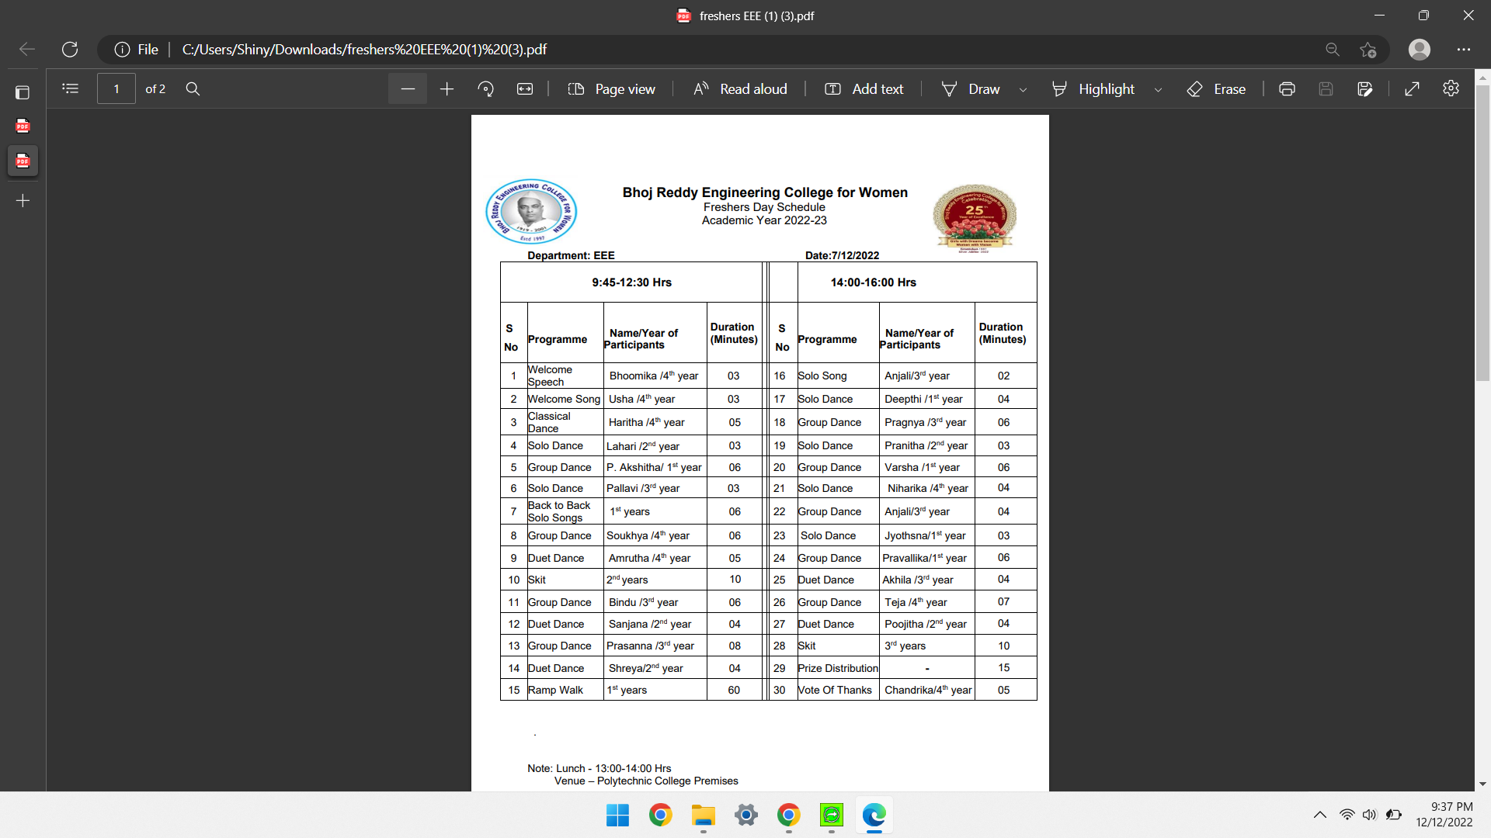
The list of programs for Freshers Day day were Solo singing, Solo dance, Duet dance, Group dance, Skit, Many students have participated enthusiastically in all the programmes. The Cultural program started at 9:45 am at Indoor Auditorium Ramdev Block with a song and followed by the scheduled dances and songs. The Cultural program was completed around 4:00Pm with vote of thanks.

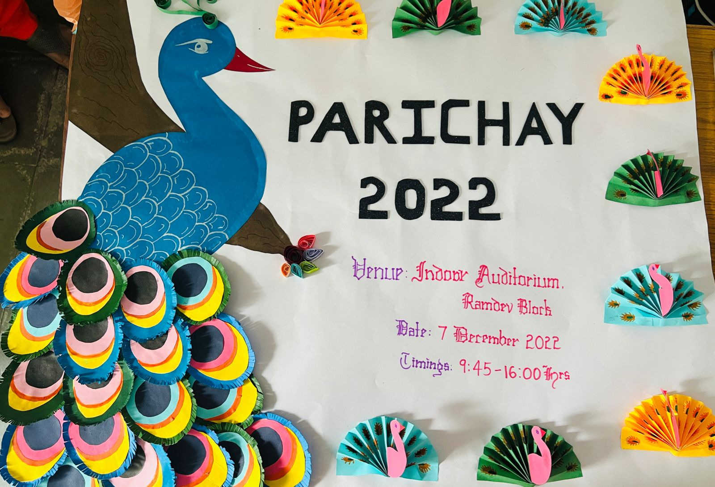

Now, coming to the winners and runners of the event
Classical Dance
1st prize- Haritha(19321A0214) from IV year EEE
Solo Dance
1st prize- Niharika(19321A0229) from IV year EEE
2nd prize-S.Deepthi (22321A0204) from I year EEE
Duet Dance
1st prize - Akhila(20321A0202) and Pallavi(20321A0224) from III year EEE
Group dance
1st prize- B.Akhila(20321A0202),G.Nandini(20321A0220),G.Prasanna(20321A0226),
Himabindu(20321A0205), Harsha(20321A0231),Yesheswini(20321A0247) and
Hari Prasanna (21325A0203) from III year EEE
2nd prize- M.Soukhya(19321A0245), N.Sushmitha(19321A0252), Veena Sravanthi(19321A0259) ,N.Divya(19321A0211), B.Divya(19321A0210), P.Sai Chandana(19321A0237), Ch.Kavya Sri(19321A0220) and Durga(19321A0212) from IV year EEE

Skit
1st prize - P.Harika(21321A0208),M.Nandini(21321A0213), K.Vijaya(21321A0237), N.Priyanka(21321A0220), P.Vasumathi(21321A0246) ,Sani Azeem(21321A0226) ,G.Reshma(21321A0223) ,Fathima Begum(21321A0206) and M.Ashwini(21321A0203) from II EEE
Solo Song
1st prize- Anjali(21325A0201) from III EEE
Title Winners (I EEE)
Miss Freshers-L.Pravallika(22321A0216)
Miss Trendy-S.Deepthi(22321A0204)
Miss Charismatic- Abhigna(22321A0220)
Miss Stunning-K.Anusha(22321A0203)
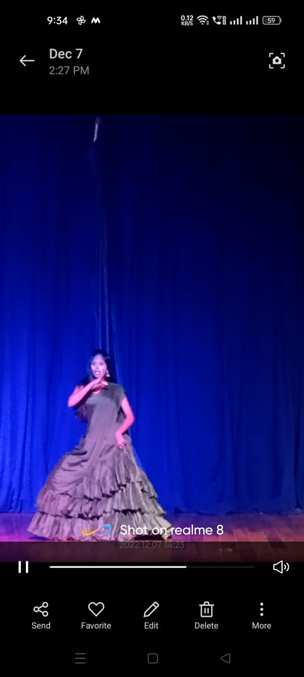
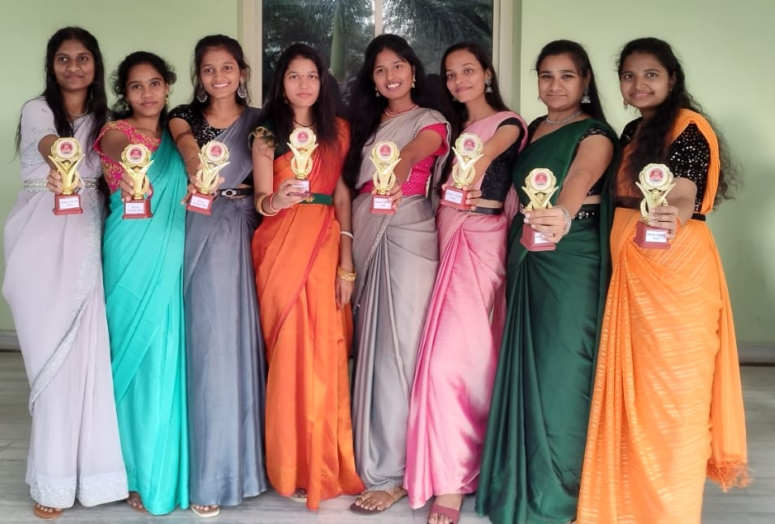
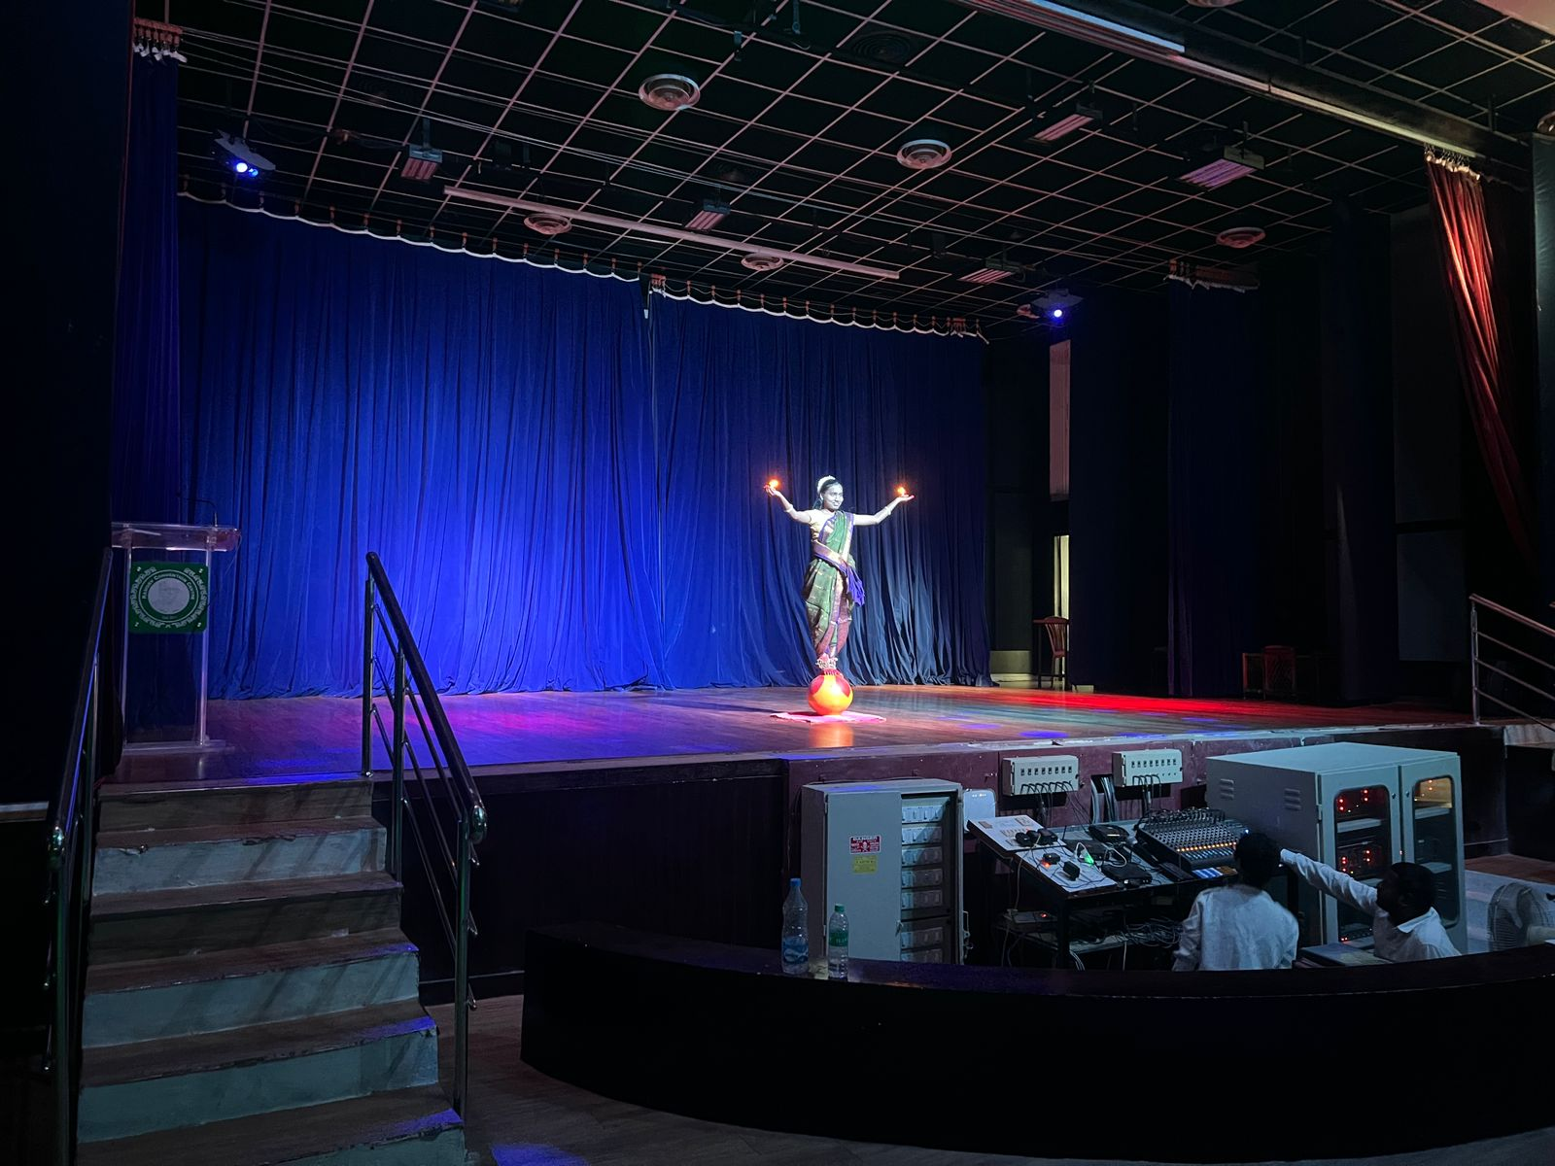
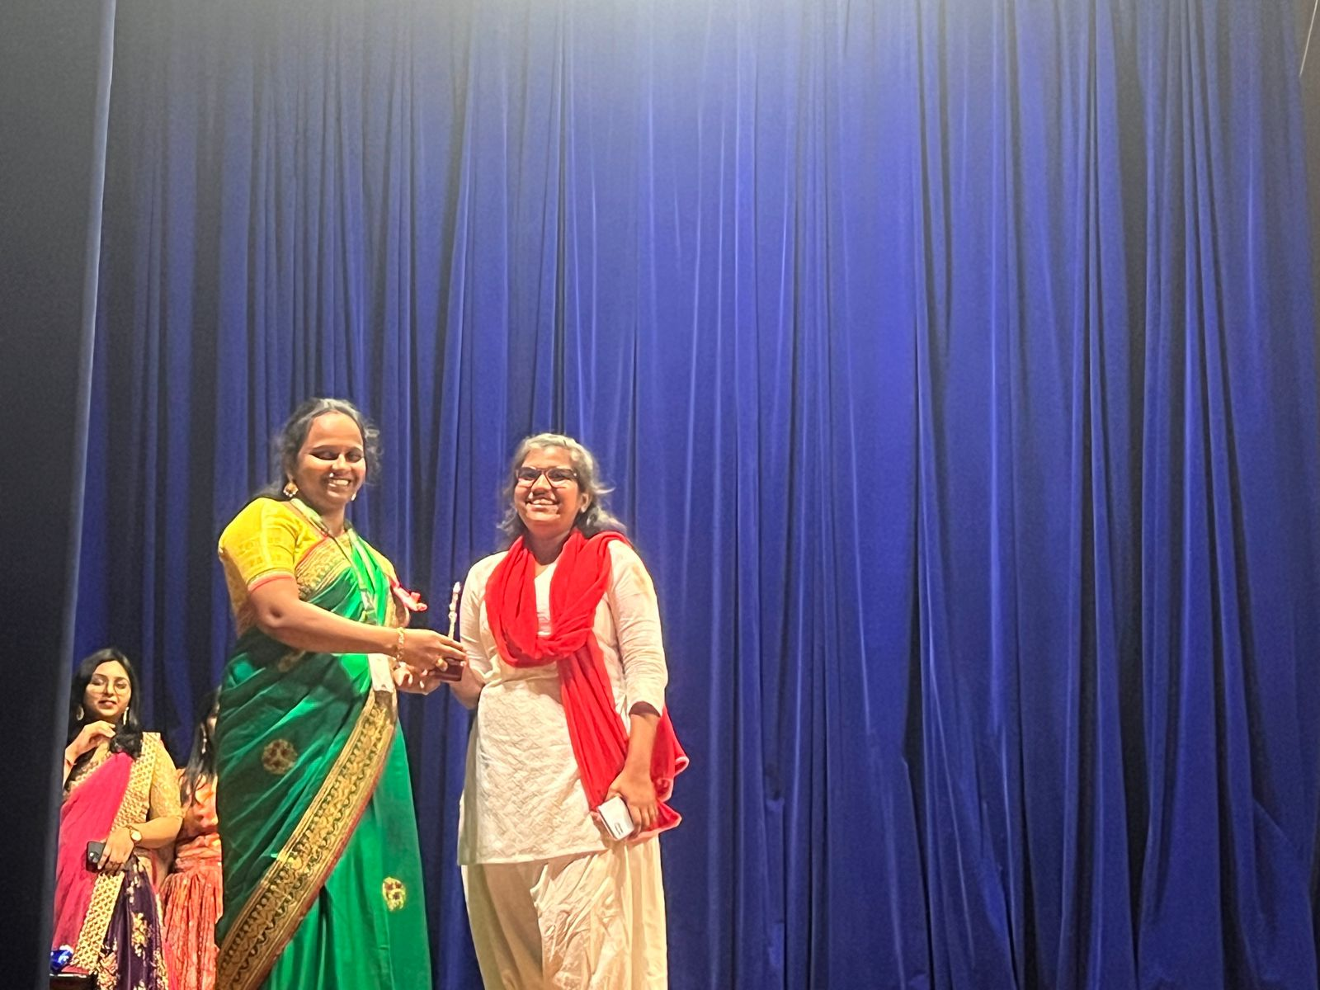
Miss Cutiepie-Pravallika(22321A0215)

