Bhoj Reddy Engineering College for Women
(Sponsored by Sangam Laxmibai Vidyapeet, approved by AICTE and affiliated to JNTUH)
Vinayanagar, IS Sadan Crossroads, Saidabad, Hyderabad – 500 059, Telangana. www.brecw.ac.in

Guest Lecture Report
Guest Lecture Banner which was conducted on 12 December 2022
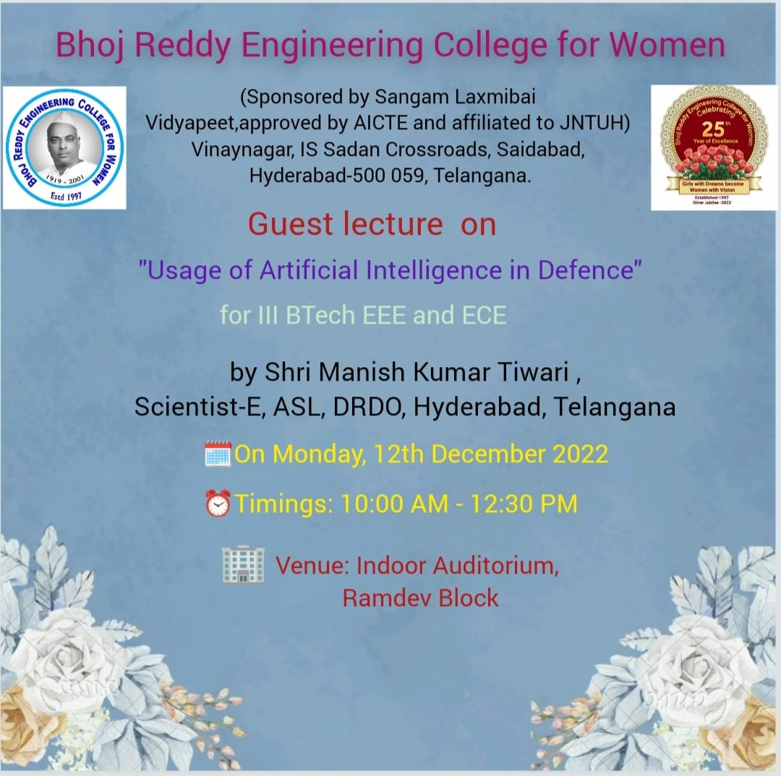

About the speaker:
Manish Kumar Tiwari, Scientist E, at Defence Research and Development Organisation (DRDO), obtained B.Tech from UP Technical University in Computer Science and Engineering and M.Tech in Software Engineering in 2009 from NIT, Allahabad.Joined DRDO in May, 2008 as Scientist ‘B’. His research work has been broadly in the area of Software Development, Testing and Artificial Intelligence. He has developed software used in AGNI Missile system.He has obtained six sigma green belt from ISI, Bangalore and Qt Development from Microsoft.He is also certified in Linux
Administration from edx Education.He has published 21 research papers in Defence science journals and 11 conference papers. He is a fellow of American society for Quality and Senior member of IEEE society.He has delivered more than 50 guest lectures at NIT and other institutes.
The speaker started the session by introduced key concepts on artificial intelligence; defining critical terms, capabilities as well as current limitations of AI. He also explained key concepts of artificial intelligence Basic algorithms were also covered during the session. This guest lecture was a good learning experience for the Students. They had the opportunity to familiarize themselves to AI using programming language whilst also having the opportunity to interact with some of the best resource persons from DRDO.
The speaker threw some light on application of artificial intelligence. The speaker concluded the lecture by explaining the importance of artificial intelligence. The lecture was very helpful for the students and staff as it gave an idea of artificial intelligence.
